Software Requirements Specification
for
Embroid-It
Version 1.0 <rough draft>
Prepared by Nathan Owens
Chris Parks
Trae Rawls

EWU Winer Quarter Senior Project
January 27, 2016

Table of Contents
Table of Contents ii
Revision History ii
1. Introduction 1
1.1 Purpose 1
1.2 Document Conventions 1
1.3 Intended Audience and Reading Suggestions 1
1.4 Product Scope 1
1.5 References 1
2. Overall Description 2
2.1 Product Perspective 2
2.2 Product Functions 2
2.3 User Classes and Characteristics 2
2.4 Operating Environment 2
2.5 Design and Implementation Constraints 2
2.6 User Documentation 2
2.7 Assumptions and Dependencies 3
3. External Interface Requirements 3
3.1 User Interfaces 3
3.2 Hardware Interfaces 3
3.3 Software Interfaces 3
3.4 Communications Interfaces 3
4. System Features 4
4.1 System Feature 1 4
4.2 System Feature 2 (and so on) 4
5. Other Nonfunctional Requirements 4
5.1 Performance Requirements 4
5.2 Safety Requirements 5
5.3 Security Requirements 5
5.4 Software Quality Attributes 5
5.5 Business Rules 5
6. Other Requirements 5
Appendix A: Glossary 5
Appendix B: Analysis Models 5
Appendix C: To Be Determined List 6

Revision History
Name | Date | Reason For Changes | Version
Nathan Owens | 2/8/16 | Created SRS rough draft | N/A

Introduction

Purpose
The Embroid-It software is an interactive application that allows the user to open, create, edit, layout, and export/save an embroidery project file for use specifically with a Brother name-brand embroidery machine.

Document Conventions
In each section of this document, requirements and specifications are listed from highest-priority to lowest-priority. Unless otherwise stated, it is assumed that higher-level requirements are inherited by lower-level detailed requirements.

Intended Audience and Reading Suggestions
This document is intended for use and reference by the developers and stakeholders involved in creating the Embroid-It software application. Section 1 identifies the scope of this document, the conventions followed during documentation, and the purpose of the software. Section 2 gives an overall description of the functionality of the software, as well as user characteristics. The third section of this document defines and describes all external interfaces associated with the Embroid-It application. Section 4 is intended for use primarily by the developers of Embroid-It. and details the use cases and system features of the software. Section 5 will identify and describe any other nonfunctional requirements, and the final section will include any other software requirements not previously mentioned. Appendices are included at the end of this document, containing additional resources.

Product Scope
All embroidery machines, both for commercial and home use, need an input file to read in, that provides the machine with necessary information for proper output. The input file provides information such as stitch color and placement, stitch patterns, stitch length, etc. There are several different file formats that embroidery machines accept as proper input, depending on the machine make and model. The Embroid-It application will allow the user to open, create, edit, and export solely PES formatted files. The PES file format is used mainly with Brother brand embroidery machines. This software will be an open source, cross-platform application that can be run on various operating systems. The goal of the Embroid-It application is to provide a free, easy-to-use environment, allowing for the user to edit and create embroidery designs, also providing a visual representation of the design.

References
IEEE. IEEE Std 830-1998 IEEE Recommended Practice for Software Requirements Specifications.

IEEE Computer Society, 1998.

Overall Description

Product Perspective
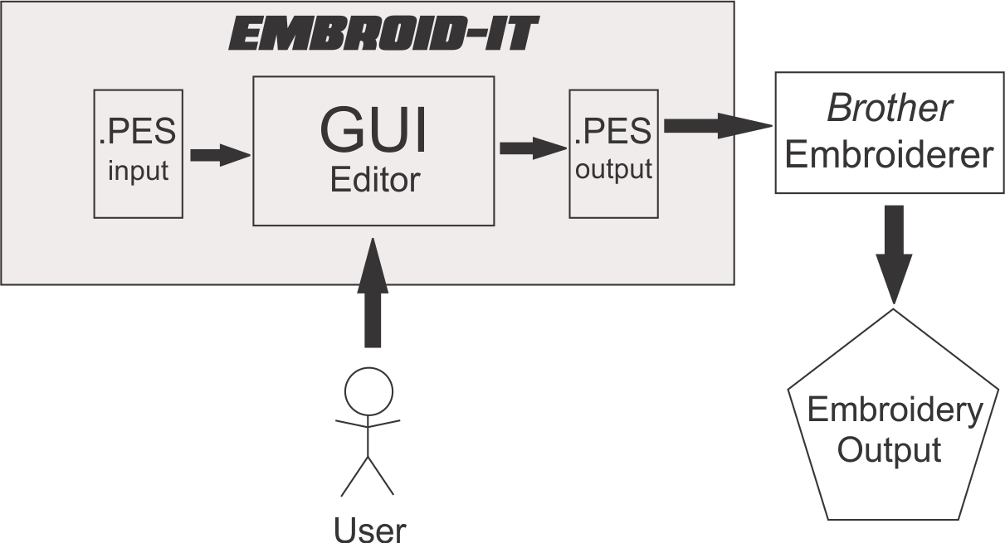

Figure 1 – System Environment

The Embroid-It software is designed as a stand-alone desktop application, to assist the user in creating, editing, and exporting an embroidery design represented in the PES file format. The application shall import PES formatted files, as well as support the creation of a new PES file. In either case, the application shall present a EEI (embroidery editing interface), allowing the user to see a visual rendering of the current design, and manipulate different aspects of the design, such as stitch color, stitch length, and stitch pattern. The EEI shall also present the user with tools to select all or portions of the project, draw basic shapes, and overlay stitches, and other features described throughout this document. The application shall also allow the user to save/export the project to a PES formatted file.

Product Functions
At minimum, the functions that the Embroid-It application shall perform are as follows:
- Allow the user to import a PES formatted file for editing.
- Allow the user to create a new embroidery project.
- Allow the user to manipulate basic aspects of the project including stitch color, stitch length, and stitch patterns.
- Allow the user to draw new basic shapes.
- Allow the user to select all or different portions of the project
- Provide a current visual representation of the project.
- Export/Save the current project as a PES formatted file.

These functions and features are described in more detail in Section 4 of this document.

User Classes and Characteristics
Users of this product are expected to have a basic knowledge and background of the embroidery process, however are not expected to learn any special set of skills or commands. Since the purpose of this product is to provide and easy-to-use environment, the application shall be basic and provide the user with necessary information to perform basic editing operations. The user is also expected to be literate in their current operating environment, having basic knowledge in file systems and desktop applications. It is expected that the user have knowledge of basic aspects of the embroidery process and definitions, such as stitch length and patterns. This software is intended only as a stand-alone application to assist the user in editing an embroidery design to use as input for on an embroidery machine, and therefore, shall not provide the user with the knowledge to use and/or run the embroidery machine.

Operating Environment
The Embroid-It software will be a cross-platform application, and will at minimum operate on the following systems and environments:
- Windows
- Apple/Mac OS
- Linux

The product will be a stand-alone desktop application, therefore once installed, will not require network access.

Design and Implementation Constraints
The first release of the Embroid-It application will be limited to only utilizing PES formatted embroidery files. If the intent is to use a PES file created by the software, the user will thus be limited to only those models of embroidery machines that are compatible with the PES file format.

User Documentation
The Embroid-It installation package will contain a “README” text document, providing the user with basic information about the application.

/*
(Other documentation/manuals? I don’t think we have discussed this in-full…do we need to write a user manual?)
*/

Assumptions and Dependencies
No assumptions or dependencies have been identified at this time.

/* Can anyone think of any assumptions or dependencies we have? */

External Interface Requirements

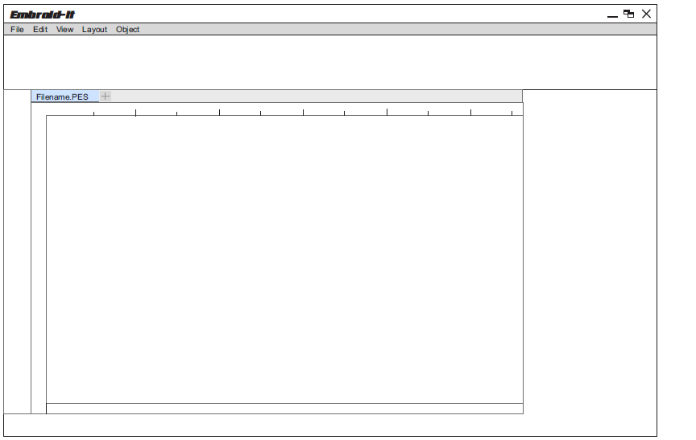
User Interfaces
Figure 2 – EEI Layout

When run, the Embroid-It application will present an EEI (Embroidery Editing Interface) for user interaction. This interface will contain a layout consisting of a menu bar, various toolbars containing different editing tools to assist the user in manipulating the embroidery project, and a canvas that will depict a visual representation of the current project. All user interaction with the software will be handled through the EEI, therefore the EEI will also provide tool buttons and/or menus for opening PES files, creating new PES files, and exporting/saving the current project to a PES formatted file.

Hardware Interfaces
None

Software Interfaces
The Embroid-It application will utilize the operating system calls to the file management system to retrieve and store PES files. The application will be responsible for all interactions with the file system, including checking whether a file exists, and navigating through directories.

**The software will preserve all information contained in a PES file that is opened and saved by the application, except where information is explicitly deleted or changed by the user prior to saving. Information that must be preserved in the PES file includes, but is not limited to: stich colors, stitch length, and stitch patterns. //should this paragraph be placed somewhere else?

Communications Interfaces
None

Use Cases
The Embroid-It application at minimum will implement the following use cases. The user should be able to perform each of these functions through the EEI user interface described in section 3.1. These cases are listed from highest-priority first. This SRS is an early stage version, therefore additional use cases can expect to be added in future versions.

Open or create new PES file
The user should be able to open an existing PES formatted file to edit and modify.

Trigger – User selects ‘open/create file’ option from file drop down menu, or clicks on an ‘open/create file’ button contained in the EEI toolbar.
Precondition – Application has been started, and EEI has been successfully opened by the application
Exceptions
- Check to see if file exists.
- Check to see if file is in PES format.

Save/Export PES file
The user should be able to save/export the current embroidery project to a PES formatted file.

Trigger – User selects ‘save file’ option from file drop down menu, or clicks on a ‘save file’ button contained in the EEI toolbar.
Precondition – A project file has been successfully opened or created.
Exceptions
- Check to make sure intended filename and path are valid.

4.3 Use shapes for design outline

The user should be able to use basic geometric shapes to use as an outline for the embroidery design.

Trigger – User clicks on corresponding shape button contained in the EEI toolbar.
Precondition – A project file has been successfully opened or created.
Exceptions
- ??
Other
- Shapes should be able to flip, rotate, and scale up or down
- User should be able to change height or width independently of each other.

4.4 Draw individual stitches within the design pattern

The user should be able to draw individual stitches within the pattern of the current design.

Trigger – User clicks on ‘draw stitch’ button contained in the EEI toolbar
Precondition – A project file has been successfully opened or created.
Exceptions
- ??
Other
- ??

Other Nonfunctional Requirements

Performance Requirements
<If there are performance requirements for the product under various circumstances, state them here and explain their rationale, to help the developers understand the intent and make suitable design choices. Specify the timing relationships for real time systems. Make such requirements as specific as possible. You may need to state performance requirements for individual functional requirements or features.>

Safety Requirements
No specific safety requirements have been identified

Security Requirements
There are no specific security requirements

Software Quality Attributes
<Specify any additional quality characteristics for the product that will be important to either the customers or the developers. Some to consider are: adaptability, availability, correctness, flexibility, interoperability, maintainability, portability, reliability, reusability, robustness, testability, and usability. Write these to be specific, quantitative, and verifiable when possible. At the least, clarify the relative preferences for various attributes, such as ease of use over ease of learning.>

Business Rules
<List any operating principles about the product, such as which individuals or roles can perform which functions under specific circumstances. These are not functional requirements in themselves, but they may imply certain functional requirements to enforce the rules.>

Other Requirements
TBD

Appendix A: Glossary
EEI (Embroidery Editing Interface) – User interface allowing for visual (non-command line) interaction between the user and the Embroid-It software.

PES – Computer aided manufacturing file that contains instructions for creating embroideries with a sewing/embroidery machine; contains codes such as “stop,” “jump,” and “trim;” also includes colors for the design from the supported Brother color palette. Mainly used by Brother embroidery machines, but also compatible with Babylock and Bernina machines.
Appendix B: Analysis Models
TBD
<Optionally, include any pertinent analysis models, such as data flow diagrams, class diagrams, state-transition diagrams, or entity-relationship diagrams.>
Appendix C: To Be Determined List
- Additional use cases
- Add models and diagrams
- Identify any other nonfunctional requirements

